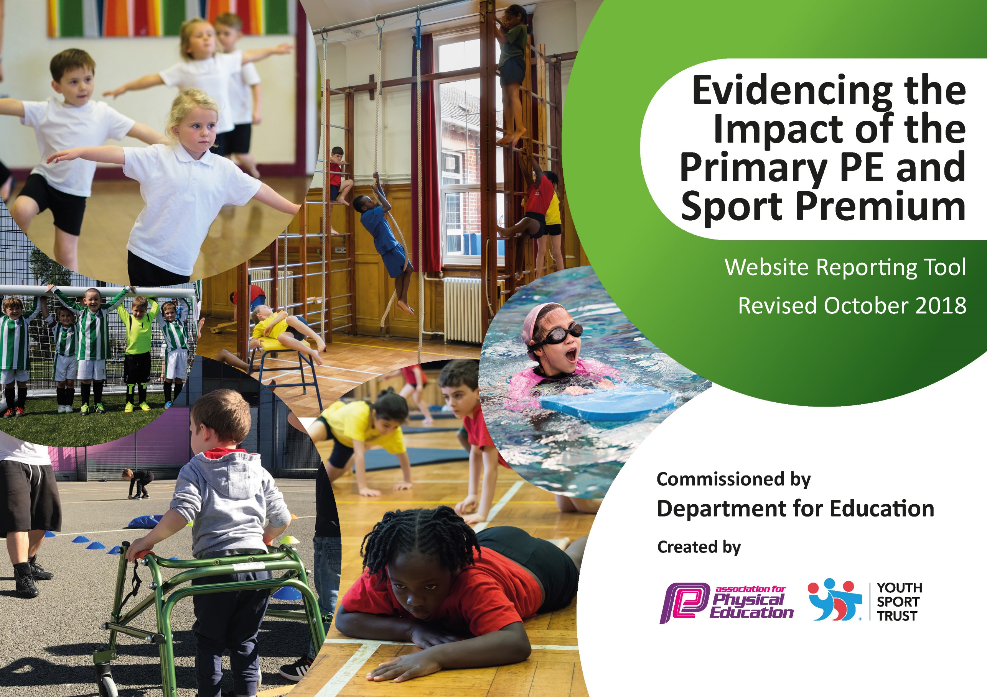
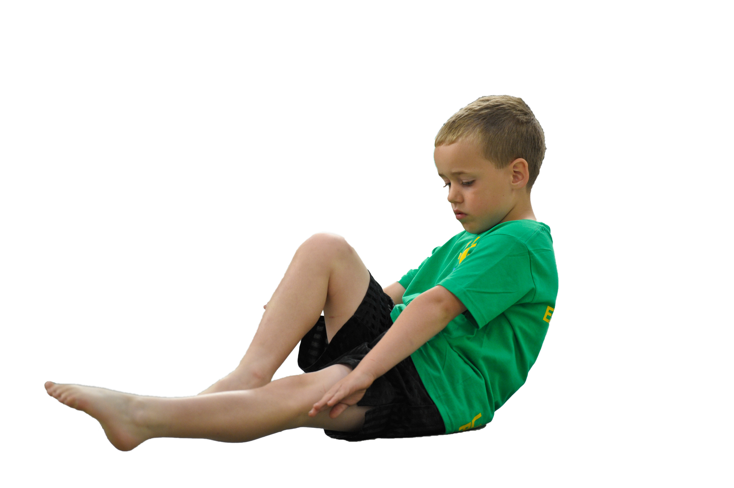
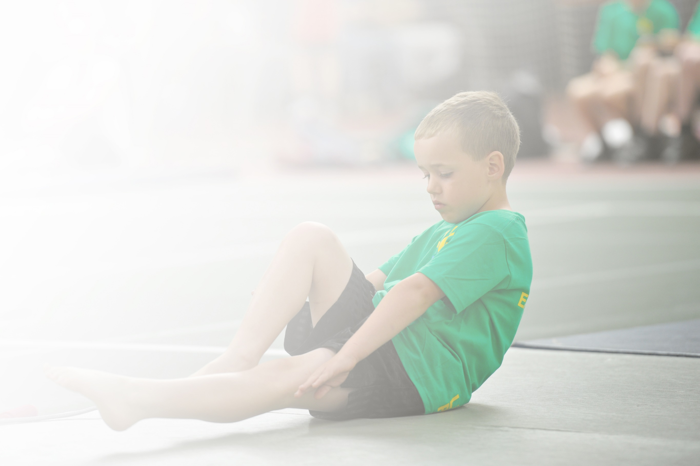
Schools must use the funding to make additional and sustainable improvements to the quality of Physical Education, Sport and Physical Activity (PESPA) they offer. This means that you should use the Primary PE and Sport Premium to:

- Develop or add to the PESPA activities that your school already offer
- Build capacity and capability within the school to ensure that improvements made now will benefit pupils joining the school in future years

Please visit gov.uk for the revised DfE guidance including the 5 key indicators across which schools should demonstrate an improvement. This document will help you to review your provision and to report
your spend. DfE encourages schools to use this template as an effective way of meeting the reporting requirements of the Primary PE and Sport Premium.

We recommend you start by reflecting on the impact of current provision and reviewing the previous
spend. Under the Ofsted Schools Inspection Framework, inspectors will assess how effectively leaders use the Primary PE and Sport Premium and measure its impact on outcomes for pupils, and how effectively governors hold them to account for this.

Schools are required to publish details of how they spend this funding as well as on the impact it has on pupils’ PE and sport participation and attainment by the end of the summer term or by 31 July 2019 at the
latest.
We recommend regularly updating the table and publishing it
on your website throughout the year, as evidence of your
ongoing review into how you are using the money to
secure maximum, sustainable impact. To see an
example of how to complete the table please
click HERE.

Support for review and reflection - considering the 5 key indicators from DfE, what development needs are a priority for your setting and your students now and why? Use the space below to reflect on previous spend, identify current need and priorities for the future.

Key achievements to date: | Areas for further improvement and baseline evidence of need:
- Paid for Swimming lessons for Pupil Premium children  - Bronze Sports Mark was achieved  - 100% of children involved in regular exercise through the Golden Mile initiative.  - The Year 5/6 girl’s football team reached the final of the Hampshire cup  - The Year 5/6 boys football team …  - Chance to Shine Coach worked with Year groups in Key Stage 1.  - Increased involvement in inter and intra competition including Cricket, Netball, Tag Rugby, Cross Country and football. Over 30 competitions or matches were undertaken over the year.  - Year 4, 5 and 6 represented the school in the Hampshire Swimming Gala  - Staff received Dance training from PE lead from Hampshire. This involved a dance staff meeting followed by one/one planning sessions with each year group.  - New planning for Gym and Dance lessons  - Competitions, sporting events and Sports day was published on the school website and in our school newsletter. | - Set up notice board to show competition news, Golden mile progress and other school or cluster information/news  - Renew Golden Mile initiative  - Achieve Silver Sports mark  - Gym and Dance training for all teachers. Level 1 Gym certification.  - Address resources issues including storage and quality and quantity of resources.  - Investigate assessment and planning of the subject.  - Further increase the quantity of extra-curricular clubs including ne activities (Ultimate Frisbee) and encourage greater participation.  - Further develop the role of Young Leaders in regards to PE and leadership.  - Ensure all children in Year 3 reach necessary swimming ability. Pay for Pupil premium children and those not reaching required level by Year 6 to have further catch up lessons.  - Create links with the community and clubs such as the Worthies football club.

Meeting national curriculum requirements for swimming and water safety | Please complete all of the below:
What percentage of your current Year 6 cohort swim competently, confidently and proficiently over a distance of at least 25 metres?  N.B. Even though your children may swim in another year please report on their attainment on leaving  primary school. | 74% swim competently
What percentage of your current Year 6 cohort use a range of strokes effectively [for example, front crawl, backstroke and breaststroke]? | 66% can use at least two different strokes effectively.
What percentage of your current Year 6 cohort perform safe self-rescue in different water-based situations? | 41% have taken part in self rescue and water-based survival.
Schools can choose to use the Primary PE and Sport Premium to provide additional provision for swimming but this must be for activity over and above the national curriculum requirements. Have you used it in this way? | Yes/No

Action Plan and Budget Tracking
Capture your intended annual spend against the 5 key indicators. Clarify the success criteria and evidence of impact that you intend to measure to evaluate for students today and for the future.

Academic Year: 2020/21 | Total fund allocated: £19,000 | Date Updated:
Key indicator 1: The engagement of all pupils in regular physical activity – Chief Medical Officer guidelines recommend that primary school children undertake at least 30 minutes of physical activity a day in school |  |  |  | Percentage of total allocation:
 |  |  |  | £17, 720 93 %
School focus with clarity on intended impact on pupils: | Actions to achieve: | Funding allocated: | Evidence and impact: | Sustainability and suggested next steps:
Purchase resources for the delivery of PE, Whole school competition, Lunch/Play times, after school club and Sports Day.  - Enables staff to deliver a more precise lesson with the aid of resources  - Creates calmer lunchtimes with less arguments or fights  - Increases pupil participation in activities  - Increases interest in sport and a healthy lifestyle  - Motivates children to perform better during Sports Day  - Prepares children for their daily learning  - Contributes towards the engagement of all pupils in regular physical activity  - Provides a broad experience of a range of sports and activities | Create adequate storage for all resources in order to ensure they remain in good working order and useable.  Storage set up for seasonal sports. Rotated where necessary.  Check resources regular and update where needed.  Resources for new sports including Quidditch, Badminton and handball. | £1500 for Whole school including resources for badminton.  £500 for lunch times and playtimes  £800 for additional playground markings.  £200 for storage to better protect new resources.
Daily Exercise Initiative  - Introduce yoga/Zumba style exercise to whole school  - Increase fitness and focus in lessons.  - Whole school participation including vulnerable groups.  - Encourage and foster competition.  - Link to other whole school initiatives like ‘Run with Mum’. | - Subscription cost  - Upgrade PA system  - Photocopy charge for printing certificates. | £1000
Pay for a lunch time play leader  - All children will have the opportunity to take part in lunch time competitions  - Aids towards increasing pupil participation in competitive sport  - Contributes towards the engagement of all pupils in regular physical activity  - Children will spend their lunch time being physically active  - The less active children are engaged in activities that they enjoy and are being encouraged to be physically active  - Identified groups of children are being provided for  - Provides a broad experience of a range of sports and activities  - Increases pupil motivation  - Raises standard of pupil performance  - Raises the profile of PE across the school. | - Regular discussions with the leader over the implementation of Lunch time activities  - Regular contact and checking how the groups are going  - Ask the children who would like to take part  - Sort the children into teams  - Sort the targeted groups of children and ensure the leader is working with them  - Have a meeting with lunch time supervisors to ensure they are aware of the leader’s role and discuss playground positioning | £2000 to £3000 for Role including training.
Pay for Pupil premium clubs, Current Year 4 swimming catch up, Year 5 Swimming Catch up for those PP children yet to meet the 25m standard.  - This enables and encourages our Pupil Premium children to take part in extra-curricular sports based activities which they may otherwise have been unable to do  - Increases interest in sport and a healthy lifestyle  - Ensures our children are confident with a life saving skill  - Helps families to allow their children to learn to swim at an affordable price | - Find out the clubs available and their cost.  - Send a letter to all pupil premium children notifying them of a free place  - Send a letter to the pupil premium children in Y3 and offer them a free swimming place  - Assess the children to see if they can swim 25m  - Keep a record and invite them to catch up swimming in the summer term  - Arrange a catch-up swimming session for the summer term | £2800  Year 4 Catch Up  £500 for Year 5 PP Catch up and clubs
Sensory Circuits Initiative:  This initiative to be introduced with a small group of children to support focus in lessons, to develop improved social interaction and fine and gross motor skills. | - Identify children in Year 3/4 and assessment their physical needs  - Train staff in teaching initiative  - Purchase resources needed including large balls, mini trampoline | £150
Develop Outdoor learning  Create outdoor spaces in the Woodland walk for children to complete team building challenges including Trust fall, Blind trail and climbing wall. | - Discuss with ORE/NW/LK/CC about key needs which incorporate Forest School ideals and outdoor education.  - Investigate other school provision  - Contact contractor and acquire at least 2 estimates. | £7270
Key indicator 2: The profile of PESSPA being raised across the school as a tool for whole school improvement |  |  |  | Percentage of total allocation:
 |  |  |  | £200 1%
School focus with clarity on intended impact on pupils: | Actions to achieve: | Funding allocated: | Evidence and impact: | Sustainability and suggested next steps:
Enroll children into the Young Ambassador Scheme  - Provides an opportunity for children to lead and manage within PE  - Adds to the provision of sports and activities we offer in school  - Aids towards increasing pupil participation in competitive sport  - Contributes towards the engagement of all pupils in regular physical activity  - Provides support for the less active children during their lunch times, having their peers present  - Provides support for the SEND children during their competitions having their peers present  - Provides the Young Ambassadors with important leadership skills which they can use to lead within their PE lessons and in their future schooling and careers  - Raises the profile of PE across the school. | Share the idea behind the role with Year 5 children  - Choose from those interested and liaise with their parents  - Keep in regular contact with the ambassadors | £200

Key indicator 3: Increased confidence, knowledge and skills of all staff in teaching PE and sport |  |  |  | Percentage of total allocation:
 |  |  |  | £580 3%
School focus with clarity on intended  impact on pupils: | Actions to achieve: | Funding  allocated: | Evidence and impact: | Sustainability and suggested  next steps:
Increase staff confidence, knowledge and expertise in Gym and Dance.  - Children become more confident and proficient in both gym and dance.  - Children are engaged and enthused by their gym and dance sessions.  - Parents share in the success of Gym and Dance by attending outcomes at least once a year. | - Planning reviewed for skills progression  - PE lead to be released to work with and support staff.  - New staff to receive Level 1 certification in gym – AA, AW, RC and OR. Also, training for support staff including AP, SE and AW.  - Refresh staff meetings for level 1 staff in gym  - Refresh and development training for all staff in dance. | £500
PE lead to attend training courses and meetings.  - This allows the lead to disseminate skills, ideas and knowledge to further enhance expertise of staff  - Outcomes to pupils are also improved through better quality teaching. | - PE lead to attend cluster meetings at Kings School on a regular basis  - Coaching courses including Lacrosse.  - PE lead to be released to work with and support staff. | PE online conference  £80
Key indicator 4: Broader experience of a range of sports and activities offered to all pupils |  |  |  | Percentage of total allocation:
 |  |  |  | £0 0%
School focus with clarity on intended  impact on pupils: | Actions to achieve: | Funding  allocated: | Evidence and impact: | Sustainability and suggested  next steps:
Chance to Shine Cricket initiative.  - Children experience high quality coaching over a 6 week block  - Teachers receive CPD and get to observe over this time.  - Opportunities to take part in competitions later in the year.  Henry Beaufort Links/Coaching.  - Teachers from Secondary school demonstrate sports or activities not offered in Kings Worthy.  - Children offered opportunities to meet staff from feeder school. Good opportunity for transition.  - Children and staff observe good practise. | - Teacher to be provided with planning  - Coach to deliver an assembly to whole school  - CPD opportunity later in the year for teachers involved.  - Links to play in competitions.  - PE lead to contact secondary school. Contact: Assistant head.  - Agree activities and sports to be demonstrated.  - Children from secondary school to attend. | No charge as new funding sourced for this year.  No charge  Total = £0
Key indicator 5: Increased participation in competitive sport |  |  |  | Percentage of total allocation:
 |  |  |  | £500 3%
School focus with clarity on intended  impact on pupils: | Actions to achieve: | Funding  allocated: | Evidence and impact: | Sustainability and suggested  next steps:
Pay for competitions and the cost of coaches/minibus’ to get there.  - Increases pupil motivation  - Enhances our inclusive provision  - Enhances a positive attitude and engagement in and towards competition  - Larger groups also allows for B and C teams to enter competitions  - Increases our links and partnerships with other schools  - Raises the profile of PE across the school  - Allows all pupils to attend competitions | Go through the list of competitions from Kings and Henry B  - Ensure all year groups have a competition to go  - Ensure a range of sporting types are entered  - Ensure there are plenty of opportunities for B and C teams  - Put the dates on the calendar and inform staff | £500 approx  Total = £500

